## Western White Pine (WWP)

**General Information**

**Cover Type Overview**

* 1,257 acres / 509 hectares
* Crosswalk to EVeg: Regional Dominance Type 1
  + Western White Pine
* Crosswalk to EVeg: Regional Dominance Type 2
  + Any
* Crosswalk to Presettlement Fire Regime Type
  + Western White Pine
* Crosswalk to LandFire Biophysical Settings
  + 0711720: Sierran-Intermontane Desert Western White Pine-White Fir Woodland

**Vegetation Description**

*Pinus monticola* is locally abundant in subalpine habitats along the west slope of the Sierra Nevada, where it may occur in small pure stands. More commonly, it mixes with *Pinus contorta* ssp. *murrayana, Pinus jeffreyi, Tsuga mertensiana*, and *Abies magnifica* at higher elevations and *Abies concolor* or *Pinus ponderosa* at lower elevations (Fites-Kaufman et al. 2007, LandFire 2007).

This system tends to be more woodland than forest in character, and the undergrowth is more open and drier, with little shrub or herbaceous cover. Tree regeneration is less prolific than in other mixed-montane conifer systems of the Cascades, Sierras and California Coast Ranges (LandFire 2007). *P. monticola* generally maintains a tree form of growth up nearly to treeline, where it is commonly replaced by other subalpine species on rocky ridges (Fites-Kaufman et al. 2007).

These forests and woodlands are marked by the absence of *Pseudotsuga menziesii*, *Pinus lambertiana*, and *Calocedrus decurrens*, and the generally drier, continental climatic conditions. In addition, the overall floristic affinities are with the Great Basin (LandFire 2007).

Understories are typically open, with moderately low shrub cover and diversity, and include *Arctostaphylos*, *Chrysolepis*, *Ceanothus*, and *Ribes*. Common herbaceous taxa include *Arnica*, *Festuca*, *Poa*, *Carex*, *Pyrola*, and *Hieracium*. In openings, *Wyethia* can be abundant (LandFire 2007).

**Distribution**

These forests and woodlands range from just above the zone of *P. ponderosa* in the montane zone, to the upper montane zone. Elevations range from 1370 m to over 2135 m (4500-7000 ft). Occurrences are found on all slopes and aspects, although more frequently on drier areas. This ecological system generally occurs on basalts, andesite, glacial till, basaltic rubble, colluvium, or volcanic ash-derived soils. These soils have characteristic features of good aeration and drainage, coarse textures, circumneutral to slightly acidic pH, an abundance of mineral material, rockiness, and periods of drought during the growing season. Climatically, this system occurs somewhat in the rainshadow of the Sierras and has a more continental regime, similar to the northern Great Basin (LandFire 2007).

**Disturbances**

**Wildfire**

Most fires in this type are low mortality fires that allow large areas of the landscape to develop mature characteristics. Occasional severe fires are driven by weather extremes (LandFire 2007). Young trees are very susceptible to mortality from fire, but mature *P. monticola* is moderately fire resistant. After a stand-replacing fire, *P. monticola* will seed in from adjacent areas. After a cool to moderate fire that leaves a mosaic of mineral soil and duff, it will reoccupy the site from seed stored in the seed bank. Overall, *P. monticola* is a fire-dependent, seral species. Fire suppression has resulted in decreased stocking levels. Periodic, stand-replacing fire or other disturbance is needed to remove competing conifers and allow *P. monticola* to develop (Griffith 1992).

Data on fire return intervals (FRIs) are available from a few review papers. Van de Water and Safford’s 2011 review paper aggregates hundreds of articles, conference proceedings, and LandFire data on fire return intervals, with an emphasis on Californian sources. For Western white pine, they report a mean FRI of 50 years, median of 42 years, mean min of 15 years and mean max of 370 years. We also include here data from the LandFire BpS model (2007), which estimates a mean FRI for replacement fire of 200 years, mean FRI for mixed fire 65 years, mean FRI for surface fire at 45 years, with an overall mean FRI of 23 years. We recalculated these numbers using condition-specific information and using only high and low mortality fire categories, which resulted in a mean FRI of 133 years for high mortality fire, 28 years for low mortality fire, and 23 years for any fire.

Table 1. Fire return intervals (years) and percentage of high versus low mortality fires. Numbers were derived from BpS model 0711720 (LandFire 2007) and Van de Water and Safford (2011).

|  |  |  |  |  |  |
| --- | --- | --- | --- | --- | --- |
| **Variant** | **Fire Mortality** | **Mean** | **Min** | **Max** | **% of Fires** |
| WWP | High | 133 | – | – | 17 |
| Low | 28 | – | – | 83 |
| All Fires | 23 | 15 | 370 | 100 |

**Other Disturbance**

Other disturbances are not currently modeled, but may, depending on the condition affected and mortality levels, reset patches to early development, maintain existing condition classes, or shift/accelerate succession to a more open condition.

**Vegetation Condition Classes**

We recognize five separate condition classes for WWP. The condition classes described below are based on the classes described in the pertinent LandFire Biophysical Setting model descriptions, which in turn were based on a “5-box” state and transition models describing major successional stages related to fire regime condition classification. According to the Fire Regime Condition Class guidebook, up to five successional classes may be utilized to describe age, size, canopy cover, and vegetation composition, ranging from early seral (post-disturbance) to late seral (such as old growth) (Barrett et al. 2010).

The WWP variant is assigned to five separate condition classes: Early Development (ED), Mid Development Open (MDO), Mid Development Closed (MDC), Late Development Open (LDO, and Late Development Closed (LDC).

**Western White Pine Variant**

**Early Development (ED)**

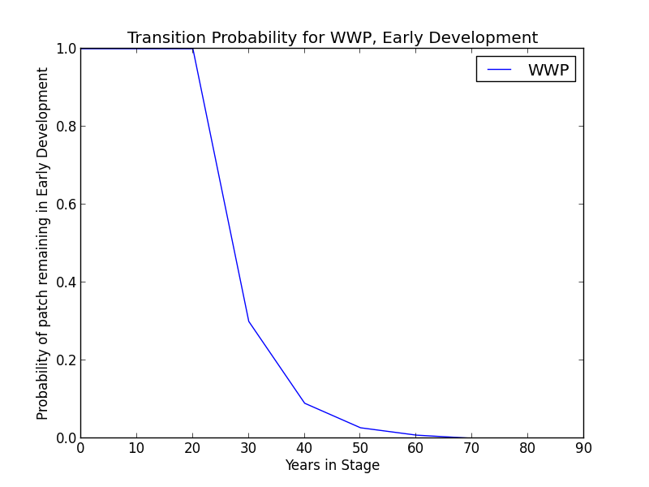**Description** Open stand of *P. monticola, A. concolor*, and *P. ponderosa*, as well as other tree seedlings mixed with grasses and shrubs. Early seral dominant species include *Ceanothus* and various grasses. A portion of these stands get into a shrub dominated stage that can persist for for a few decades (LandFire 2007).

**Succession Transition** In the absence of disturbance, this class will begin transitioning to an MD condition class after 30 years at a rate of 0.7 per time step. At 70 years, all stands will have succeeded. The transition to MDO is twice as likely as transition to MDC.

**Wildfire Transition** High mortality wildfire (100% of fires in this condition) recycles the patch through the ED condition. Low mortality wildfire is not modeled for this condition.

**Mid Development – Open (MDO)**

**Description** Open stand of early seral tree species. Heterogeneous ground cover of grasses, forbs, and shrubs.Trees present are pole to medium sized conifers with canopy cover less than 40%. Conifer species likely present include *P. monticola, A. concolor*, and *P. ponderosa* (LandFire 2007).

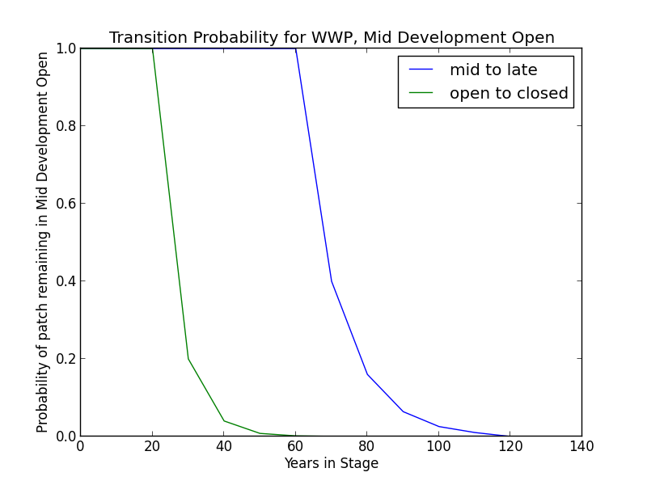

**Succession Transition** This condition will maintain under low mortality disturbance, but after 30 years without fire it begins transitioning to MDC at a rate of 0.8 per time step. Succession to LDO occurs once the patch has been in mid development for 70 years. The rate of succession per time step is 0.6. After 120 years, all stands will have succeeded.

**Wildfire Transition** High mortality wildfire (9.1% of fires in this condition) recycles the patch through the ED condition. Low mortality wildfire (90.9%%) maintains the patch in MDO.

**Mid Development – Closed (MDC)**

**Description** Sparse ground cover of grasses, forbs, and shrubs; moderate to dense cover of trees. Conifers are pole to medium-sized, with canopy cover over 40%.Forests of this type rarely, if ever, exceed 80% canopy closure even in closed, dense conditions. Conifer species likely present include *P. monticola, A. concolor*, and *P. ponderosa* (LandFire 2007).

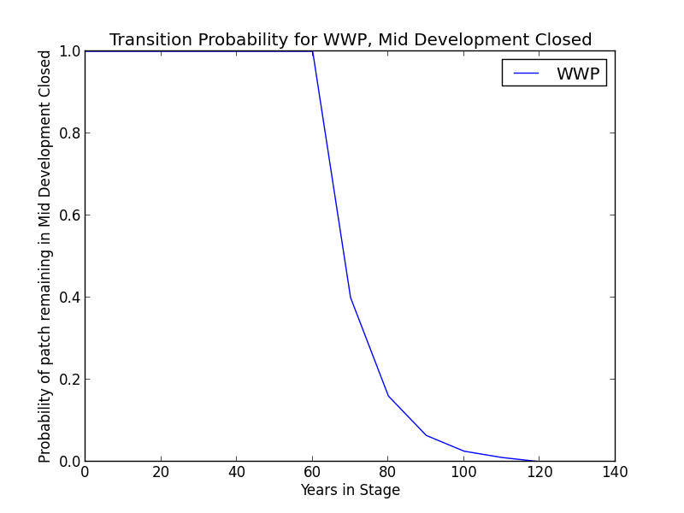

**Succession Transition** Succession to LDC occurs once the patch has been in mid development for 70 years. The rate of succession per time step is 0.6. After 120 years, all stands will have succeeded.

**Wildfire Transition** High mortality wildfire (16.7% of fires in this condition) recycles the patch through the ED condition. Low mortality wildfire (83.3%%) opens the stand up to MDO 80% of the time; otherwise, the patch remains in MDC.

**Late Development – Open (LDO)**

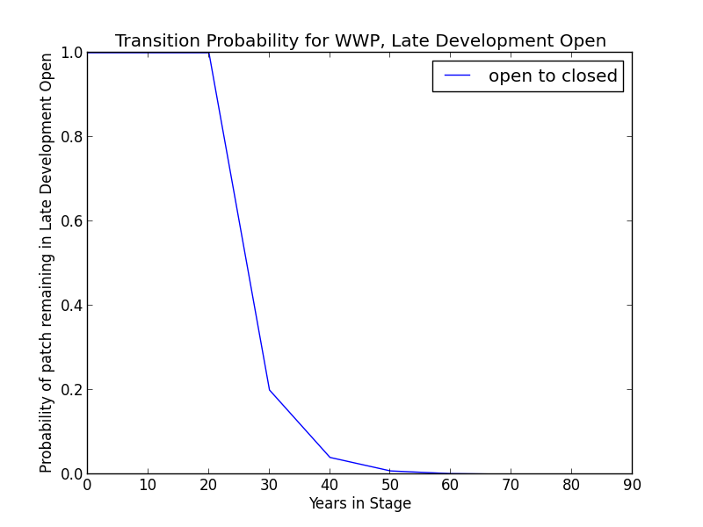

**Description** Open stands of large trees, primarily *P. monticola, A. concolor*, and *P. ponderosa.* Canopy cover is less than 40% (LandFire 2007).

**Succession Transition** This class will maintain under low mortality disturbance, but after 30 years without fire, this class succeeds to LDC at a rate of 0.8 per timestep.

**Wildfire Transition** High mortality wildfire (9.1% of fires in this condition) recycles the patch through the ED condition. Low mortality wildfire (90.9%) maintains the patch in LDO.

**Late Development – Closed (LDC)**

**Description** Closed stands of large trees, primarily *P. monticola, A. concolor*, and *P. ponderosa*. Forests in this landcover type rarely exceed 80% canopy closure even in closed, dense conditions. Canopy cover exceeds 40%.

**Succession Transition** This class will maintain in the absence of disturbance.

**Wildfire Transition** High mortality wildfire (16.7% of fires in this condition) recycles the patch through the ED condition. Low mortality wildfire (83.3%%) opens the stand up to LDO 80% of the time; otherwise, the patch remains in LDC.

**Condition Classification**

Table 2. Classification of cover condition for SMC. Diameter at Breast Height (DBH) and Cover From Above (CFA) values taken from EVeg polygons. DBH categories are: null, 0-0.9”, 1-4.9”, 5-9.9”, 10-19.9”, 20-29.9”, 30”+. CFA categories are null, 0-10%, 10-20%, … , 90-100%. Each row in the table below should be read with a boolean AND across each column.

|  |  |  |  |  |  |
| --- | --- | --- | --- | --- | --- |
| Cover Condition | Overstory Tree  Diameter 1 (DBH) | Overstory Tree  Diameter 2 (DBH) | Total Tree  CFA (%) | Conifer  CFA (%) | Hardwood  CFA (%) |
| Early All | 0-4.9” | any | any | any | any |
| Mid Open | 5-19.9” | any | <40 | any | any |
| Mid Closed | 5-19.9” | any | null | >40 | any |
| Late Open | 20”+ | any | <40 | any | any |
| Late Closed | 20”+ | any | >40 | any | any |

**Draft Model**

(See PDF) Disturbance-Succession model for WWP.

**References**

Barrett, S., D. Havlina, J. Jones, W. Hann, C. Frame, D. Hamilton, K. Schon, T. Demeo, L. Hutter, and J. Menakis. *Interagency Fire Regime Condition Class Guidebook*. Version 3.0. USDA Forest Service, US Department of the Interior, and The Nature Conservancy, 2010. <http://www.frcc.gov>. Accessed 5 June 2013.

Griffith, Randy Scott. 1993. “Pinus monticola.” In: Fire Effects Information System, [Online]. U.S. Department of Agriculture, Forest Service, Rocky Mountain Research Station, Fire Sciences Laboratory (Producer). <http://www.fs.fed.us/database/feis/>. [Accessed 4 December 2012].

Fites-Kaufman, Jo Ann, Phil Rundel, Nathan Stephenson, and Dave A. Wixelman. “Montane and Subalpine Vegetation of the Sierra Nevada and Cascade Ranges.” In *Terrestrial Vegetation of California, 3rd Edition*, edited by Michael Barbour, Todd Keeler-Wolf, and Allan A. Schoenherr, 456-501. Berkeley and Los Angeles: University of California Press, 2007.

LandFire. “Biophysical Setting Models.” Biophysical Setting 0711720: Sierran-Intermontane Desert Western White Pine-White Fir Woodland. 2007. LANDFIRE Project, U.S. Department of Agriculture, Forest Service; U.S. Department of the Interior. <http://www.landfire.gov/national_veg_models_op2.php>. Accessed 30 November 2012.

Skinner, Carl N. and Chi-Ru Chang. “Fire Regimes, Past and Present.” *Sierra Nevada Ecosystem Project: Final report to Congress, vol. II, Assessments and scientific basis for management options*. Davis: University of California, Centers for Water and Wildland Resources, 1996.

Van de Water, Kip M. and Hugh D. Safford. “A Summary of Fire Frequency Estimates for California Vegetation Before Euro-American Settlement.” *Fire Ecology* 7.3 (2011): 26-57. doi: 10.4996/fireecology.0703026.